Areas of Learning | Learning Objective  (taken from Development Matters) | Learning Experiences Offered |  | Evaluation/ Observations
 |  | Possible adult directed teaching | Opportunities for children to explore & apply
Personal, Social and Emotional Development  (Circle time) | Listens to others one to one or in small groups, when conversation interests them.  Listens and responds to ideas expressed by others in conversation or discussion.  Uses vocabulary focused on objects and people that are of particular importance to them. | Warm up:  Remind ch about the importance of good listening in school. How can the ch show you that they are listening. Ask the children to copy you as you mime getting up in the morning, getting dressed, washing, cleaning your teeth and brushing your hair. Talk the children through your actions while you are performing them.  Main activity: Why am I special? Being unique  Read extract from ‘Oh the Places you will go’ – Dr Seuss  "I Can" Chart  Talk about what the children can do. Have each child say something that they know how to do. List what each child says on a chart. Example: I can ride a bike. I can set the table. I can do a somersault. Discuss how we are all unique because we are all different and we are all special. | My Body Jigsaw  Help child trace a body part outline on paper. Children to write down all the things they can think of that make them special.
Physical Development  (PE) | 40-60 months Experiments with different ways of moving.  Early Learning Goal Children show good control and co-ordination in large and small movements. They move confidently in a range of ways, safely negotiating space. | Swimming Coach
Literacy | 40-60 months Uses vocabulary and forms of speech that are increasingly influenced by their experiences of books.  30-50months  Joins in with repeated refrains and anticipates key events and phrases in rhymes and stories. | Read Green Eggs and Ham. Spot all the rhyming words as you read. As children become familiar with the pattern of the text encourage children to complete the repeated text.  Talking Partner : Can you think of something that you don’t like eating that your Mum/Dad try to get you to eat? Peas/Brussel sprouts  Allow time for children to give their responses. | Cooking Magazines/Recipe cards and Cook Books  Can children talk about what they can see do they recognise any intial letters?  Children to cut up recipe cards and magazines of food they do like.
 | 30-50months  Beginning to be aware of the way stories are structured.  40-60months  Gives meaning to marks they make as they draw, write and paint.  Begins to break the flow of speech into words. | Recap Story Green Eggs and Ham. Introduce Tales Toolkit resources to find Character, Setting, Problem and Solution.  Model then creating your own Green Eggs and Ham stories with characters and problem (food). Choose items with children and model writing sentences Spider Man (character)will you eat the purple potatoes. I will not (problem)said Spiderman and spun a web to get away (solution) | Children to use Tales Toolkit resources to create their own story. Have a basket of characters, a basket of unusual coloured foods(problem) real or photos ie purple carrots, white strawberries etc  Children to record their story on the Tales toolkit templates.  LAPS Character and problem – sometimes give meaning to their drawings  MAPS Character, setting, problem – give meaning to the marks they make.  RW Mark making with Vegetables ie writing with carrots, printing with potatoes, apples etc  Include familiar/popular characters

Mathematics | Week 3-6 White Rose  Recognise some numerals of personal significance. Recognises numerals 1 to 5.  Counts up to three or four objects by saying one number name for each item. Count actions or objects which cannot be moved.  Selects the correct numeral to represent 1 to 5 objects. Counts an irregular arrangement of up to 5 objects. | Starter  Beat out a number on a drum. Can you count and say how many beats there were? Show me on your fingers. Ext Is there only one way to show me?  Main Activity  Introduce Numicom pieces on whiteboard. Give each child a musical instrument. Teacher to then pull a piece from a bag and children bang/shake their instrument the app times. | Children to work in pairs. Give each child a bag with numerals and Numicon 1 – 5 in. Child A chooses a numeral or Numicon and keeps it hidden. They bang a drum (or hop/clap/skip) the correct number of times. Child B counts and then finds the corresponding Numicon or number from their bag. Do they match?  LAPS 1-5  MAPS 1-10  HAPS 10+
 |  | Starter  With their eyes closed, children listen and count aloud as teacher drops cubes into a jar. Can you show me on one hand how many cubes I used? Can you use two hands? How many different ways can you make the number using your fingers?  Main Activity  Take the children outside to see towers built with the large construction. Which is the tallest? Which has 4 bricks? Which has less than 4? How many more do we need to add/takeaway to make? | Children work in pairs. One child finds Numicon in feely bag and identifies number by counting not looking. Partner has to build a tower with correct number of duplo bricks. Are they the same? (If not) Can you make them the same?  LAPS 1-5  MAPS 1-10  HAPS 10+
Understanding the World  Forest School | Looks closely at similarities, differences, patterns and change. | Before going outside talk to the children about changes in seasons. Can they remember the hot Summer months. What has changed? Highlight cooler weather, shorter days, more rain, birds migrating, animals hibernating, leaves falling.  Tell the children you are going on an Autumn walk to search for signs of Autumn. | 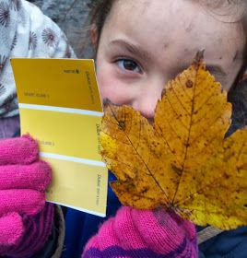  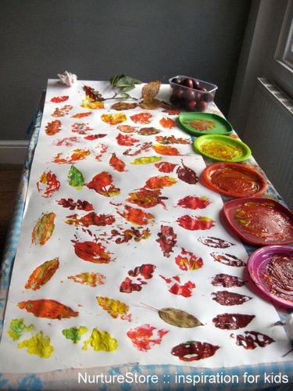  Leaf Printing on Tarmac with TA  Colour Matching with leaves and paint cards.
Expressive Arts and Design | Plays alongside other children who are engaged in the same theme.  Plays cooperatively as part of a group to develop and act out a narrative. | Set up a Green, Eggs and Ham restaurant.  Play alongside the children to develop narrative and imaginative play. | Adults to introduce different foods for children to try in the Green Eggs and Ham restaurant’.

