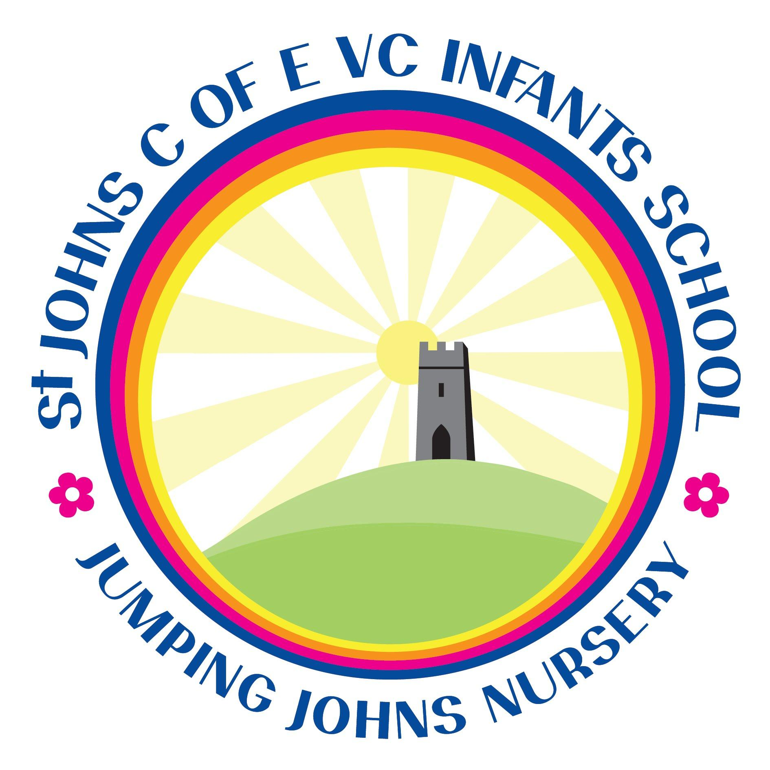
Contingency planning for outbreaks
Aspect of school | Action
A local outbreak | If St. John’s C of E VC Infants’ School is made aware of a local outbreak, the PHE health protection team or the local authority may advise the school to close. Preparations will be made by way of a contingency plan so that learning can still continue and the community can remain safe.
A part closure | If Infection affects a member of our school community and a case is confirmed  the school would have to follow direct guidance and risk assessment from Public Health England. This could lead to part or whole school closure. Parents of families affected  will be contacted by Parentpay and ClassDojo.
Individual children isolating | If a child at our school is required to self isolate not due to illness for more than 2 days teachers will provide support and home learning via ClassDojo or in a paper version.
Remote education support | St. John’s C of E VC Infants’ School needs to be in the position to offer immediate remote education if there was a local outbreak or part closure and subsequent lockdown.  Our immediate response will be the following: (as per lockdown Summer term 2020)  - Ensure all children are able to access and log on to Class Dojo and know their individual logins for Sumdog. Staff to support families who struggled or did not engage with Class Dojo in previous term.  - Children in Key Stage One are to take home their individual stationery packs and their current exercise books plus reading books  - Teachers will share lessons via Class Dojo (as per lockdown Summer 2020) and share links to YouTube, BBC Bitesize.  - Teachers will arrange Zoom meetings with children that require additional support , as deemed necessary.  - Parents will be able to take photos of their children’s learning and submit work via Class Dojo so that teachers can monitor progress and offer supportive feedback.  - Class Dojo will be used to communicate between teacher and parents.  Chosen learning activities will follow our curriculum rolling programme and will be of high quality. All teachers will use this consistently to support online learning. Teachers will also have weekly planning meetings via Google Drive.  Where children can’t access the internet, children will receive home-learning packs (paper-based) to complete. Staff will post or deliver as necessary. Efforts will be made to ensure vulnerable/disadvantaged families are not further disadvantaged by their lack of technology in the household.  The principles for delivery will be as follows:  - Children will receive learning opportunities for a range of subjects each day  - Learning will be sequenced as per our current curriculum map for KS1 as well as Areas of Learning for Foundation Stage  - Explanations will be made by the teacher using Class Dojo, video links to age appropriate sites or BBC Bitesize.  - Work will be checked and feedback via Class Dojo  - Parents can message individual Teachers via Class Dojo  - Pupils with SEND will be offered appropriately pitched work, alongside packages made available through their class teacher or SENDCo.

